Name :
Hafsa Waseem
Roll no :
Su92-bssem-s24-014
Subject :
Mad (lab)
Submitted to :
Sir Muhammad Abdullah
Question no 1 :
Code :
import 'package:flutter/material.dart';
void main() {
runApp(MyApp());
}
class MyApp extends StatelessWidget {
@override
Widget build(BuildContext context) {
return MaterialApp(
debugShowCheckedModeBanner: false, // Debug banner remove
home: DemoScreen(),
);
}
}
class DemoScreen extends StatelessWidget {
@override
Widget build(BuildContext context) {
return Scaffold(
appBar: AppBar(
title: Text("Demo Project"),
centerTitle: false,
),
body: Center(
child: Text(
"DEBUG Banner Removed Successfully",
style: TextStyle(
fontSize: 16,
),
),
),
);
}
}
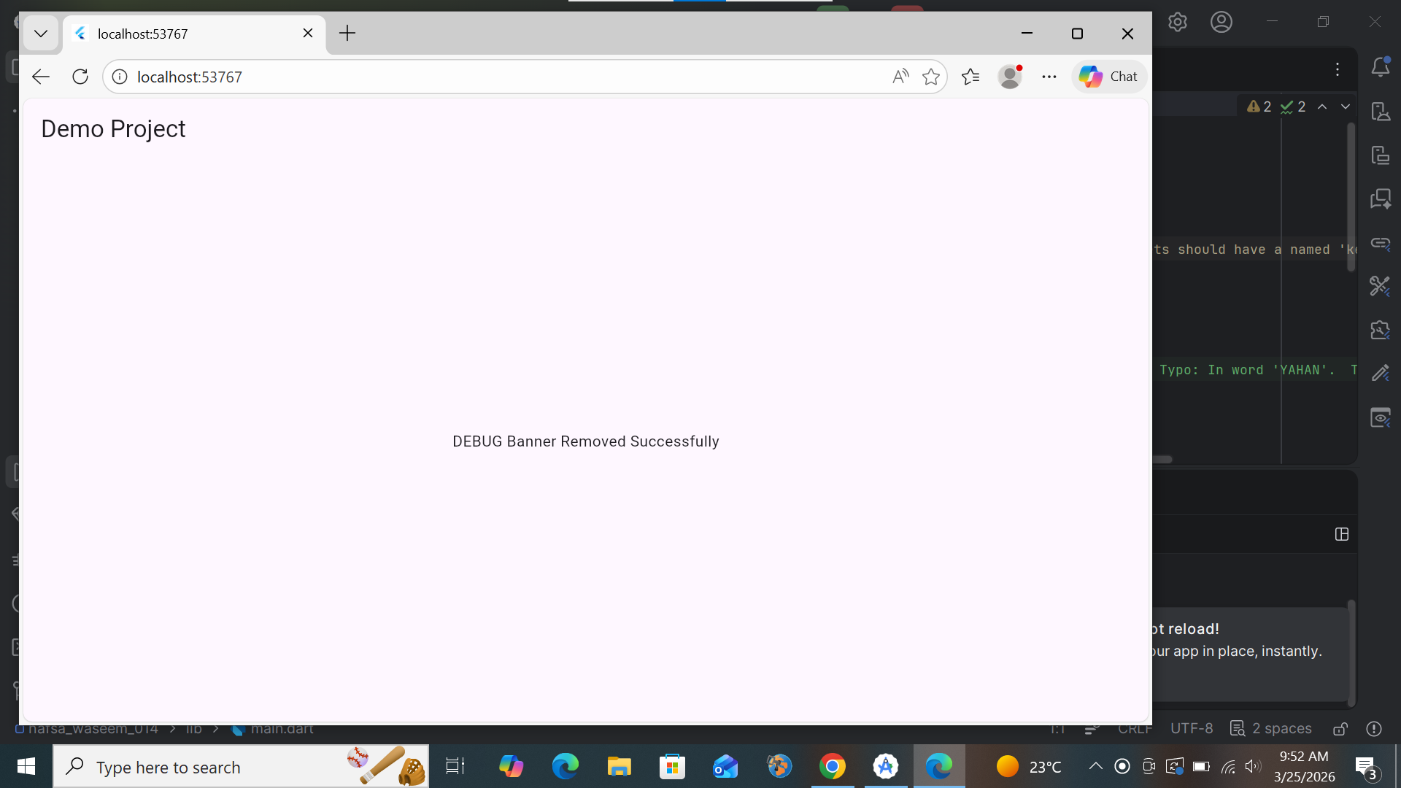

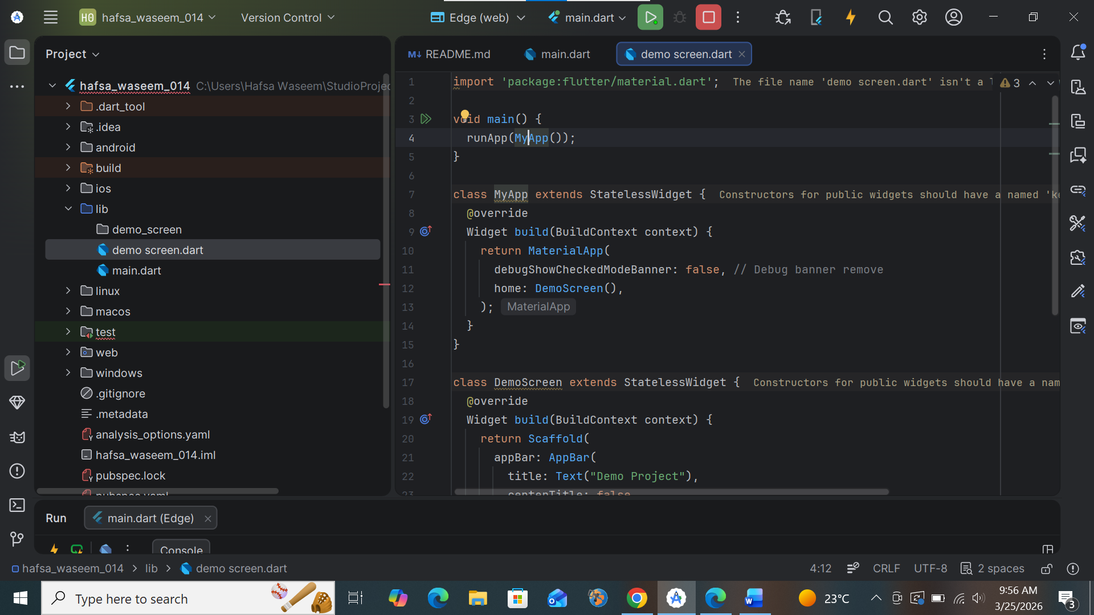

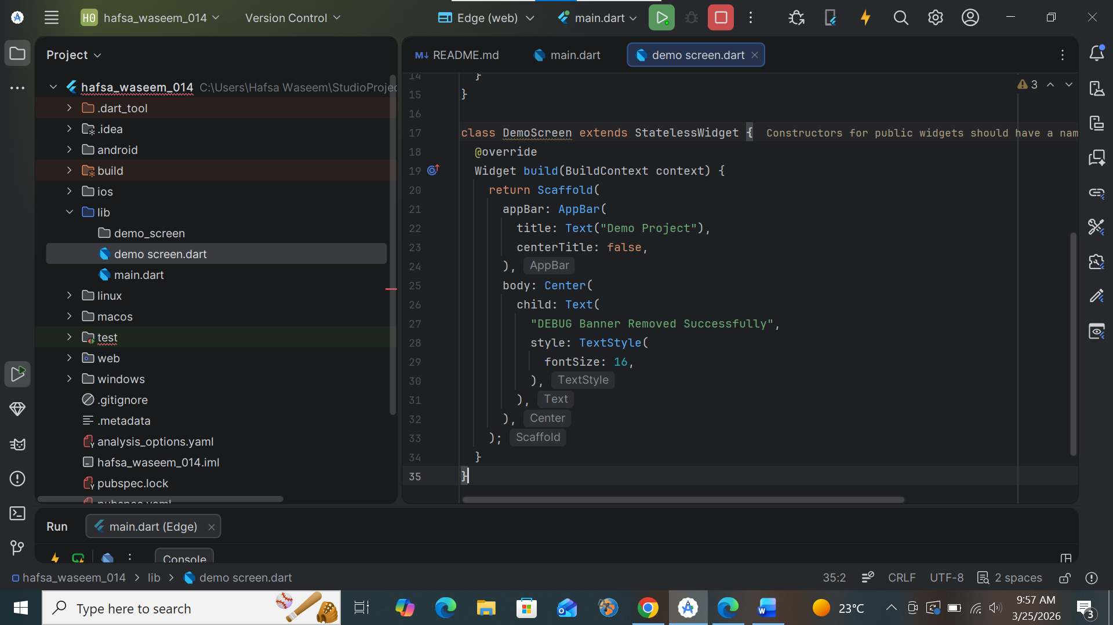

Question no 2:
